**BY**

**EMMANUEL DURU**

**MATRIC NUMBER: 2502665**

**PART B**

**TEAM 32**

**PROFESSOR WOLFGANG RENZ**

**A and B:**

1. **CommandWords:**

This class holds and recognize all commands with the option of (as “go”,”back”, “quit”, “help”) words which is known to the game.

**2. Room:**

A room represents the scenario or relatively the location in the game. Which processes the game to connect to other rooms via exits.

**3. Command:**

This class compounds information of strings that is inserted by the user. This composed of two strings.

The command also runs a check and verifies if the command words, making it <null> if it is valid or basically an invalid command.

**4. Parser:**

The paser reads user input (System.in) and returns the commands an object of the class Command. If the input is not known as a command, it returns the command object marked as an unknown command.

1. **Game:**

This connects, creates and initializes all other classes; it creates all availability for rooms, the parser and starts the game. It also defines the evaluation and executes the commands returned by the parser.

**A - Game:**

The state of the Game object is “outside the main entrance of the university”. The method is createRooms().

**B- Room:**

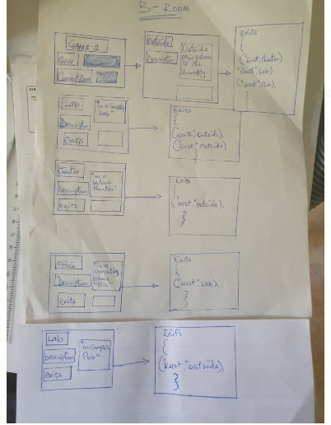

**GAME PROPOSAL: “SAVIOUR”**

Saviour is a game to be designed for a successful mission of an encrypted and classified information in a letter form, this letter is meant to be delivered to the president of United State Of America. This item is also needed by some barons because their criminal records are computed in the letter and will get them behind bars if the letter gets to the president. SAVIOUR is meant to embark on this mission with some weapons for self-defense against the bad guys.

**RULES:**

* “SAVIOUR**”**  endeavors not to be killed by the bad guys., for any reason he gets killed that should be the end of the game.
* “SAVIOUR” has to successfully defend himself from the barons till the letter is been delivered to its destination (*president of the united states of america*).

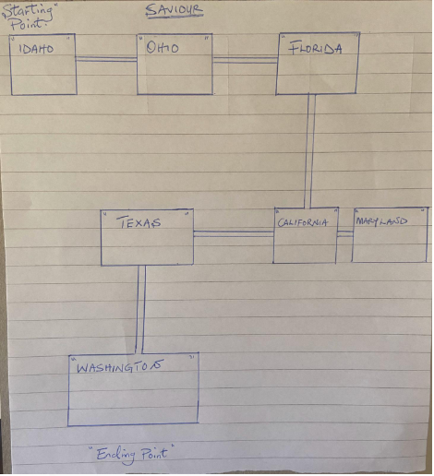

FINAL LAB REPORT

**ITEM:**

* Classified information (letter) saviour is meant to pick up the aformentioned item at ohio
* A weapon (AK 47) which is to be picked up at florida



The functionalities of the above game plan is duly illustrated in the attached file: named saviour where all codes are written with correspondent to the game.